MySQL: Es un sistema muy popular de bases de datos, propiedad de Oracle, el más usado a nivel global.

Comenzó con un conjunto de funcionalidades más bien reducidas, pero que a día de hoy lo podemos considerar de grado empresarial.

MariaDB: Es un SGBD completamente compatible con MySQL creado por la comunidad, por lo que no pertenece a ninguna empresa.

En realidad es un «fork» de MySQL, aunque desde su creación se ha ido separando del proyecto inicial, publicando distintas mejoras.

PostgreSQL: Es el SGBD más potente del mercado, no solo por su funcionalidad, sino también por la carga que puede llegar a soportar.

No está tan extendido como MySQL, pero también resulta muy popular en aquellos proyectos de cierta envergadura.

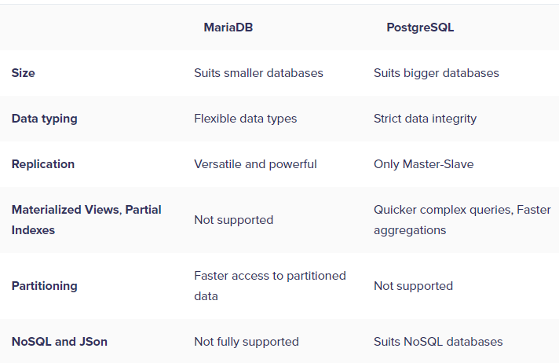

PostgreSQL

Offers faster reads and writes

hence it’s the preferred database in cases where speed of data access and turnaround time matter a lot.

it is more strictly typed

PostgreSQL has a lot of advanced features to offer such as Materialized Views, and Partial Indexes, which helps in optimizing the Database performance.

Materialized Views

Prior to executing a frequent query, Materialized Views allow precalculating expensive Joins and Aggregation operations and storing the results in a table in the Database.

This can increase the performance of complex queries that are fired frequently and access a large amount of data to get their results.

This is useful if you have a large dataset with many huge tables, which need to be joined frequently to create aggregates.

Partial Indexes

Another feature that speeds up queries on large and complex Databases, is Partial Indexes.

Partial indexes are created on query results and not on every row of a table (unlike traditional indexes).

In most cases, queries target only a subset of the rows in a table, based on recency/high activity.

If a partial index is created for query results that arise from these frequently accessed rows, this leads to much faster query execution.

MariaDB has a much smaller footprint than Postgre,

ideal for smaller databases that need to respond quickly, and are running on smaller machines.

MariaDB supports partitioning via sharding, whereas PostgreSQL does not support partitioning of its table(s). This improves MariaDB’s query performance and availability.

Also, you can store frequently accessed recent data in a separate partition,

whereas less accessed historical data can reside in some other partition, leading to increased access speeds.

MariaDB does not support JSON directly, though there are workarounds that you can implement to get JSON working on MariaDB.

In contrast, PostgreSQL has inherently good support for JSON and lends itself well for NoSQL requirements.